Was Peter Parley Disabled?

Stephen Krewson

Table of Contents

## Note

*Explain context for small group readers.*

## Introduction

*Already written; revise and make it fit with outline. This section needs to inform the reader about who Peter Parley was and what archive will be used to animate him.*

## "He ain't Peter Parley"

*This section connects Goodrich's own disability and representational networks with the afterlives of the Parley character and its distributors.*

**Plan**

* [DONE] A trip to the South; footnoting the engravers
* [Written, work it in] importance of Crusoe
* The "Parley" name and brand
* Hannah More and Parley Porter as model; More's interest in Cogswell (166)
* Back to the material and textual sources
  + brother CA Goodrich: Columbian scenes (two publictions)
  + Woodbridge and Alice Cogswell and mental "machinery"
  + "Advances in Education"
* Strange case of the missing gout: never explicitly mentioned in the main sources; only in Recollections footnote
  + In fact, gout explicitly typed in Bible Gazetteer as harming one's relationship with God
* Connection to discourse of 19C sentimentality and sick children
* Physical disability, invalids and narrative "validity", mental disability, by accident vs. by birth, etc.

The reason Samuel Goodrich could not possibly be Peter Parley, according to the young boy in Savannah, was that "he hasn't got his foot bound up, and he don't walk with a crutch!" So keen was the boy's dismay that he told his grandfather he wouldn't have "any thing to do with" Goodrich. (Goodrich 323) This anecdote features in Letter 50 of the *Recollections*, in which Goodrich tours the South. The trip culminated in a public reception in New Orleans in March of 1846 at which the author and "friend of education" was toasted by the leading lights of the city's lyceum. Domestic travel presented Goodrich, then 52, with first-hand evidence of his character's popularity. Both adults and children welcomed him "under the name of the fictitious hero whom I had made to tell my stories." As the lyceum president put it: "Mr. Goodrich, or, as we all love to call you, Peter Parley..." (324) The lyceum speechifying documented in the letter traffics in the old ideas of character as a way for authors to inculcate good morals and live on after death. But Goodrich hints at a more complex authorial situation when he admits that, at times, he "underwent rather sharp cross-questioning":

I, who had undertaken to teach truth, was forced to confess that fiction lay at the foundation of my scheme! My innocent young readers, however, did not suspect me: they had taken all I had said as positively true, and I was of course Peter Parley himself. (322)

Goodrich then dramatizes a scene of interrogation in Mobile, Alabama, in which he owns up to an eight-year-old girl that he has not, in fact, been in prison in Africa or even in Africa at all.

The eight-year-old girl's quiz about the reliability of *Tales about Africa* and the young boy's aversion to the crutchless Goodrich represent two different kinds of truth-seeking behavior, conditioned by age.[1] On one view, widely represented in the scholarship on children's literature, growing out of what Goodrich calls the "innocent young reader" stage means learning to take pleasure in one's ability to switch between the fictional and the real, not in fantasy itself. But the juxtaposed reactions of Goodrich's southern readers point to a different economy of character, one in which consistency and availability rather than a bright line dviding truth from fiction are paramount.[2] Because Goodrich writes in the "useful and entertaining knowledge" genre, the plausibility of his travel writing depends in large part upon how he manages that genre's norms of textual compilation and reuse. A first-person serialized narrator like Parley presents certain difficulties. An editor, either silently or through a virtualized editorial persona, could straightforwardly compile from a range of natural-historical dispatches. But making one character responsible for *all* the facts and adventures in a globetrotting series pushed beyond the limits of plausibility. As a result, the facts might come to be seen in a less factual light. Goodrich, "who had undertaken to teach truth," feels this tension when he speaks to his "young friends" in person.

On the one hand a genre problem: how to incorporate a frame character into "penny magazine"-style prose without undercutting the text's payload of "useful" (even if sensationalized) facts? On the other, a visual inconsistency between an author and his creation. This latter problem has as much to do with techniques of celebrity and capitalist advertising as with literary form. But insofar as both problems are about validity, the figure of the *invalid* provides a way to connect them. The story of how Parley became disabled starts with the story of how Goodrich's personality became sutured to Parley in the first place. Disability hastened their coextension. The inaugural Parley book, the sextodecimo *Tales about America* (1827), had been published anonymously. Goodrich recollects in Letter 47 that he divulged his authorship only to his wife and sister because of literary shyness and the fact that "nursery literature had not then acquired the respect in the eyes of the world it now enjoys." (279) Soon enough, though, the word got out. Certainly by 1832, when Goodrich was already drafting up Parley licensing deals to stem the flow of pirated British editions.[3]

Parley caused Goodrich "endless vexations" in relation to copyright; but in a quite literal sense he almost killed him upon arrival. In the four years following *Tales about America*, Goodrich worked 14-hour days, dictating to his wife on account of his strained eyesight. In the spring of 1832, he experienced a nervous breakdown and suffered heart palpitations worrying enough to send him off to Europe to convalesce. Compare the initial depiction of Parley in 1827 with those in 1830 and 1831. The 1827 wood engraving (unsigned, but likely done by a Boston workshop) depicts an older gentlemen with a walking stick. The visual emphasis is on *walking*, since Parley is striding away from what is likely the Massachusetts State House at the top right of the vignette.[4] The later Parleys are no longer anchored to their home city of Boston but are domestically laid up in chairs, with bandaged right feet. The walking stick has morphed into a crutch, with its distinct underarm support. Goodrich declines to "weary" the reader with the details of this "busy and absorbed period" of his life (280). But the shock of Parley, in terms of the character's unexpected commercial success and the ensuing incitement to overwork, registers iconographically in a walking disability. The quickness of this physical decline is humorously embedded in the frontispiece wood engraving to the *Method of Telling about Geography*: Parley reclines grumpily by the hearth, warding off the approach of seven children. Above him on the wall? A large framed portait of the 1827 Parley, walking confidently away from the state house and onto the Boston Common.[5]

The perambulating Parley and the bum leg Parley were each memorable in their own way. Stephen Dedalus remembers the former in *Portrait of the Artist*:

History was all about those men and what they did and that was what Peter Parley's Tales about Greece and Rome were all about. Peter Parley himself was on the first page in a picture. There was a road over a heath with grass at the side and little bushes: and Peter Parley had a broad hat like a Protestant minister and a big stick and he was walking fast along the road to Greece and Rome.

Joyce's source for this reference, which comes at the critical juncture where Stephen is summoning the courage to appeal to Father X about his unfair beating at school, was likely a late-1890s Glaswegian edition of Parley's Greek and Roman tales, which first appeared in the United States "as historical compends" in 1832-33.[6] Cross-Atlantic differences in Parley iconography, and the whole question of Parley's socio-political footing (Protestant, Whig, and so forth) merit future discussion. The point for now is that Joyce's source is based on the 1827 Parley cut, with its road winding over the heath and through the small shrubs. The outcome of a young reader's (or young, researching author's) encounter with Parley was contingent on the editions available in their historical time and place: either the fast-walking or the lame Parley might end up being stickier, the stuff of adult nostalgia or free indirect musing. Writing from France in the 1850s, however, Goodrich

The little book entitled "*Parley's Method of Telling about Geography to Children*," had a picture, drawn by Tisdale, representing Parley sitting in a chair, with his lame foot bound up, and a crutch at his side, while he is saying to the boys around--"Take care, don't touch my gouty toe; if you do, I won't tell you any more stories!" Of this work two millions were sold, and of course Parley and his crutch were pretty generally associated together, in the minds of children. (323-324n.)

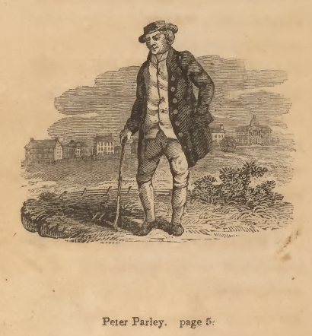

First edition. Boston: S. G. Goodrich, 1827, "HERE I am. My name is Peter Parley. I am an old man. I am very grey and lame. But I have seen a great many things, and had a great many adventures in my time, and I love to talk about them."

Abel Bowen, engraving of Massachusetts "New State House." Boston: Pub, 1828.

Abel Bowen, engraving of Massachusetts "New State House." Boston: Pub, 1828.

http://americanhistoricalstaffordshire.com/pottery/printed-designs/sources/state-house-boston

http://americanhistoricalstaffordshire.com/pottery/printed-designs/patterns/state-house-boston-stubbs

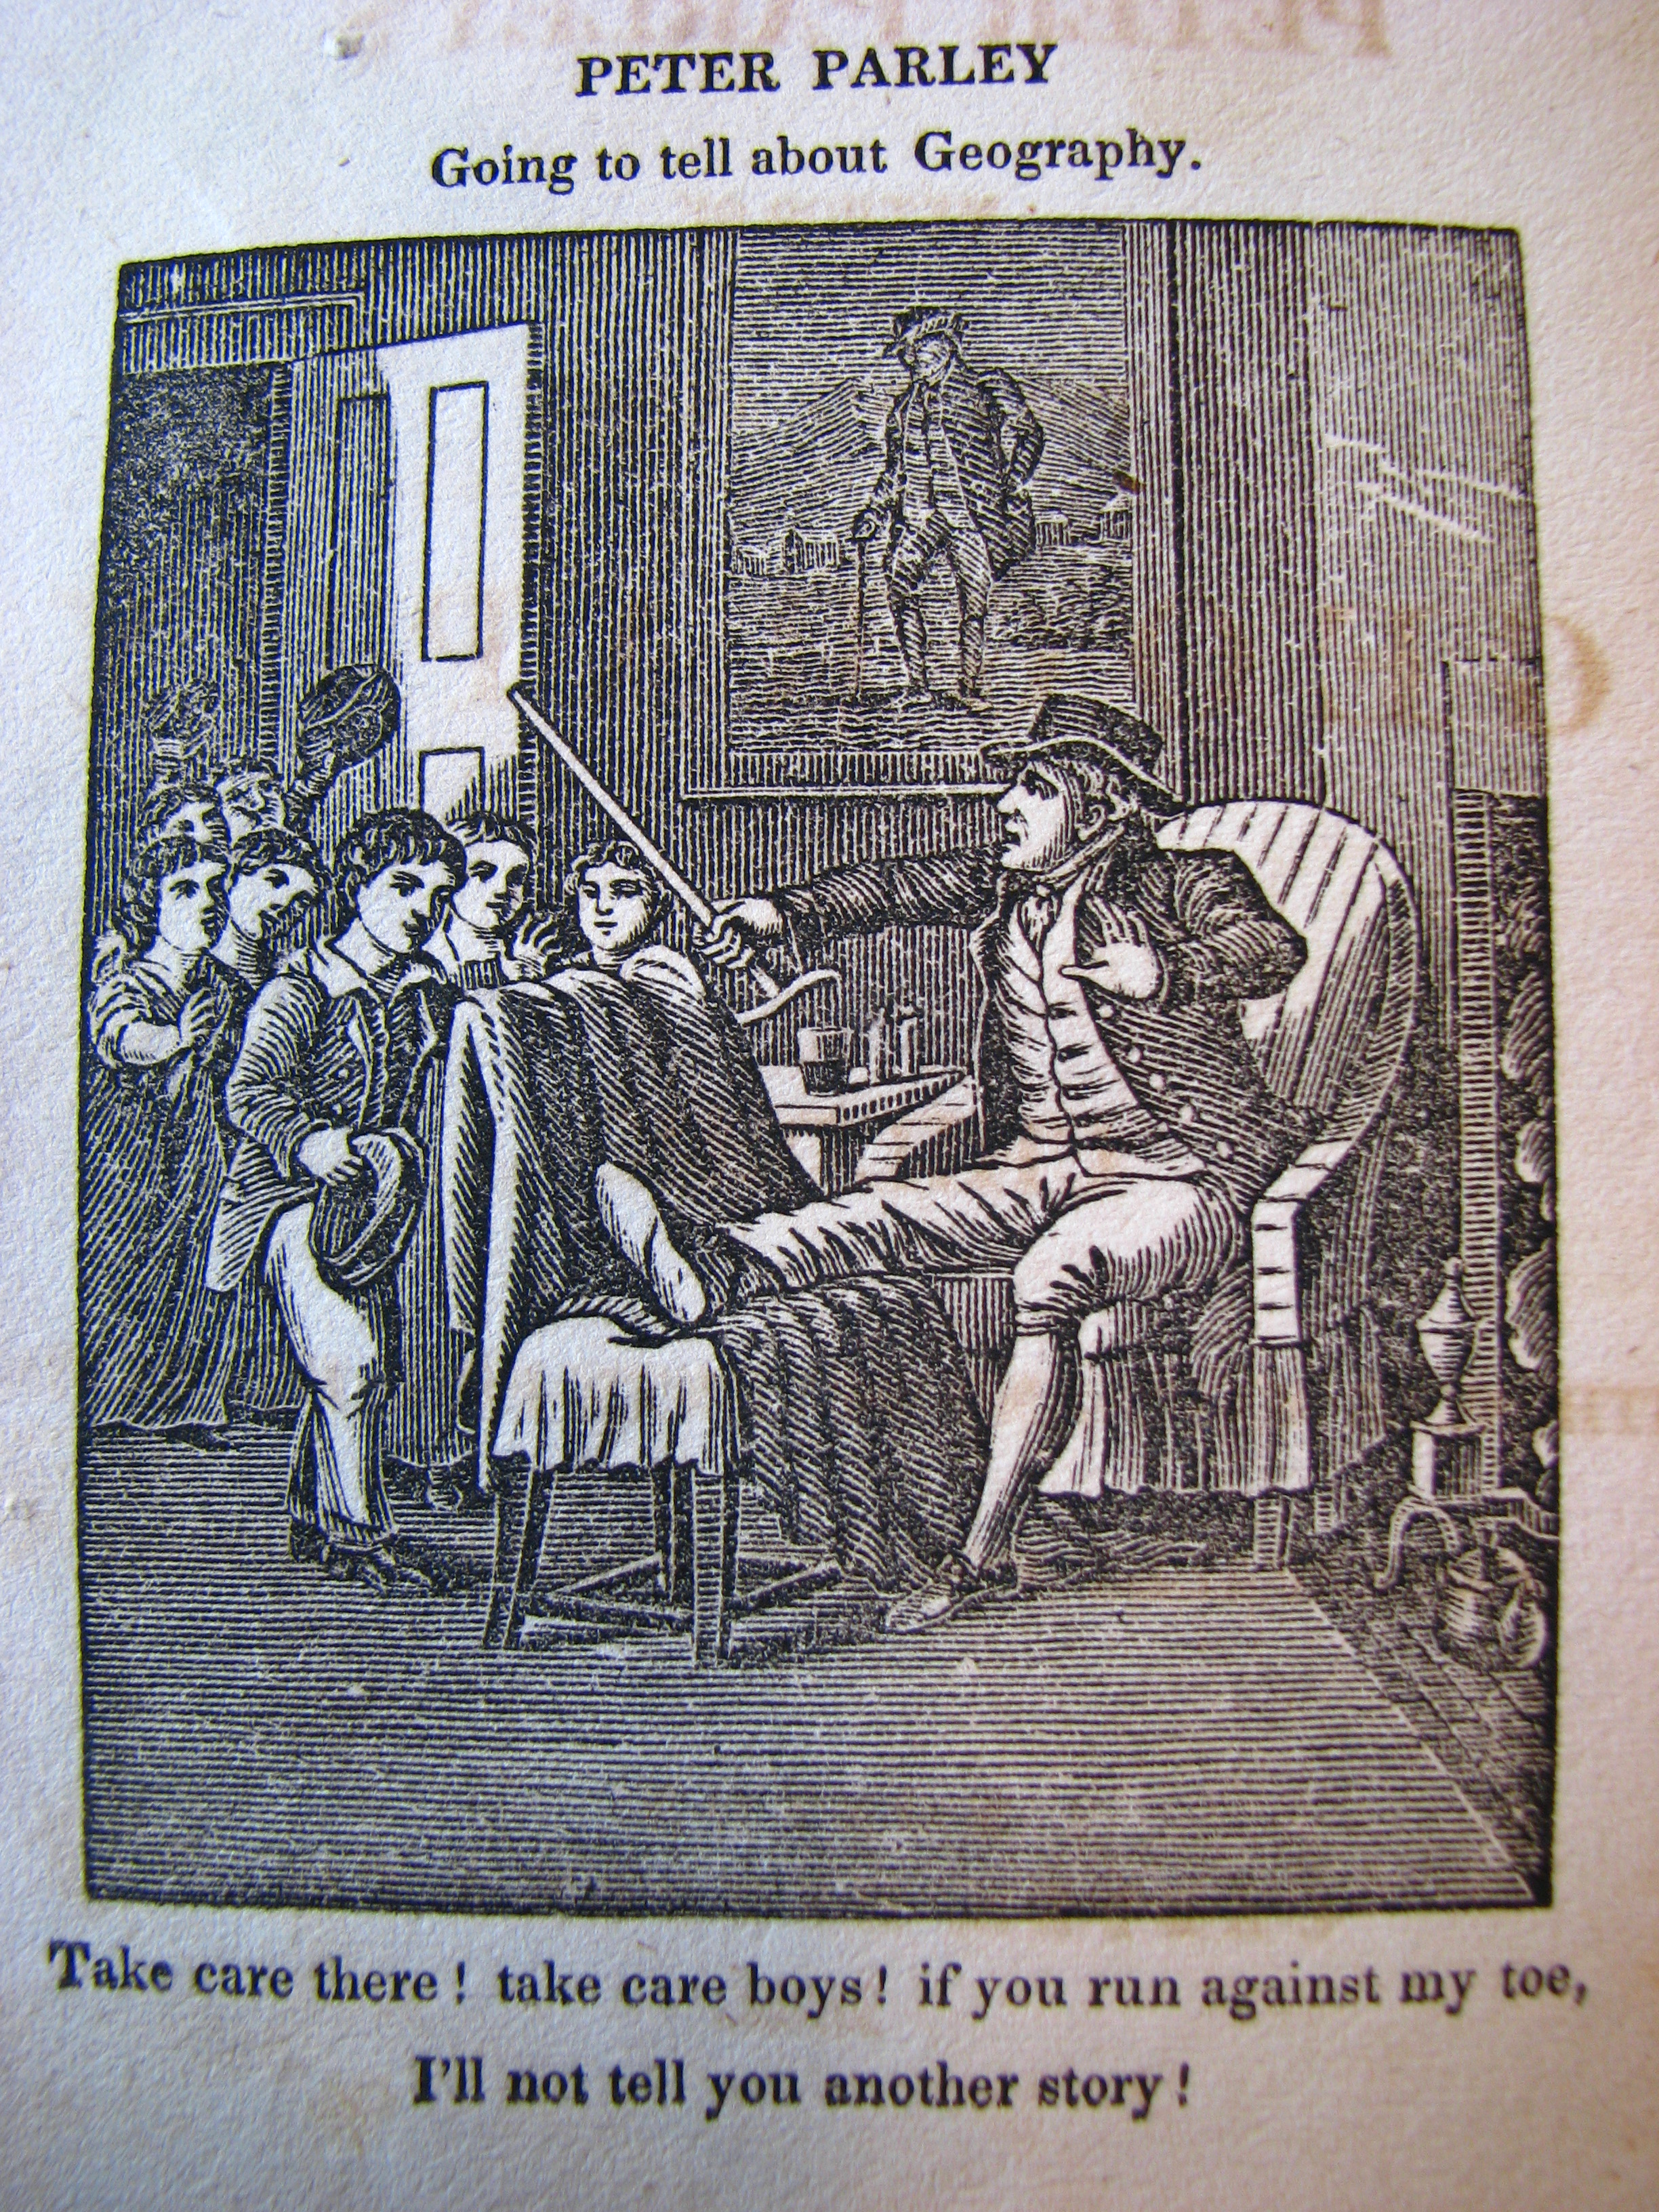

*Method of Telling about Geography*. First edition. Hartford: H. and F. J. Huntington, 1830. "Take care there! take care boys! if you run against my toes, I'll not tell you another story!" The word "gout" does not appear in this text. Note the original portrait of Parley on the wall! The preface to this text, signed P. P., deals with fictionality and genre. Same cuts are reused as in *Tales about America*. Especially the South America section which goes back to Woodbridge and perhaps Malte-Brun.

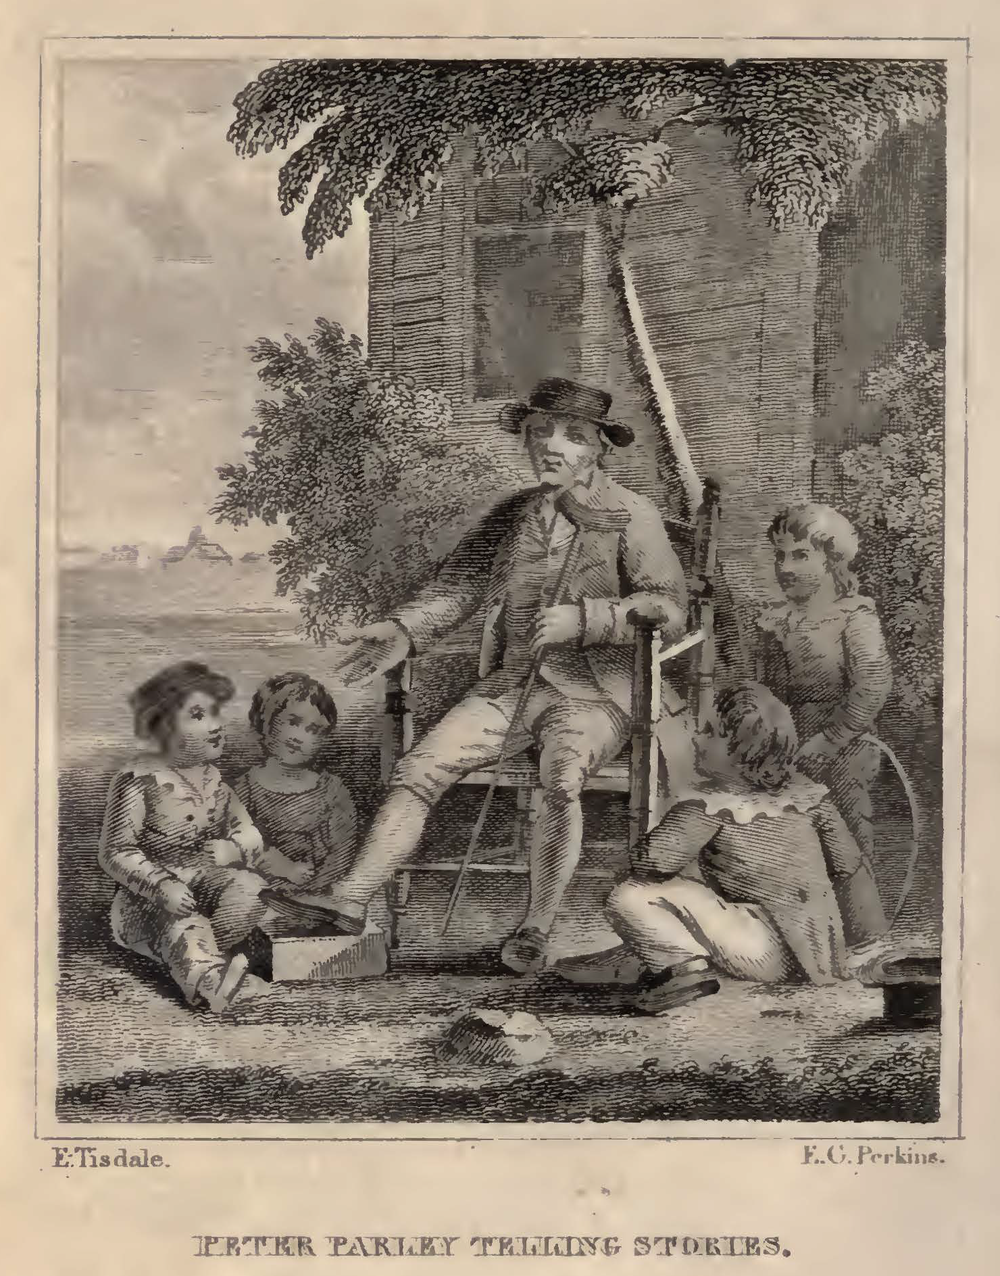 ###############################################################################

Disability can be read as addressing this problem by widening the gap between the situation of a tale's telling and the notional context in which it took place.

If character an effect of visual iconography. Goodrich footnotes the boy's exclamation that "he ain't Peter Parley."

[Show the pictures. Justify why I am NOT writing a reception history in the usual sense. Actually, the gout thing seems to not have been important. This disease would have had unfavorable connotations. Start Friday by using the Bourrier book; Parley as mix between C18 humor and C19 pathos.]

**Sources**

* Goodrich, Recollections (Goodrich)
* Pfliegl, "Parley as Brand"
* Brewer, Afterlife of Character
* Russell, Am. Journal on Parley's "avowed reuse"

## Practical Education at the Limit

Woodbridge, Gallaudet, Howe.

## Disabled Bodies, Enabled Attention?

The disabled pay attention in different ways. Close reading of Parley's magazine passage. Close reading of the Parley book. How norms for attention changed.

## TODO

* Complete outline
* Decide on sources
* Define what I mean by disability
* Contrast physical to mental impairment in Goodrich's world (the list of narrators with mental disability in modernist fiction is huge)
* Caspar Hauser in Parley's Magazine
* Key role of Alice Cogswell
* https://www.princeton.edu/~graphicarts/2008/10/index.html Track down Bowen's signature
* Who signed the "H" in the Parley print?

## Works Cited

Goodrich, Samuel G. *Recollections of a Lifetime, or Men and Things I Have Seen: In a Series of Familiar Letters to a Friend, Historical, Biographical, Anecdotical, and Descriptive.* Edited by Richard C. Valentine et al., Miller, Orton and Mulligan, 1857.

1. *Tales about Africa* was the fifth of the Parley books and was first published in 1830.
2. The fact that such switching is how adult's conceptualize the pleasure of fiction should warn us about this approach. See Crain, Lesnik-Oberstein, Sanchez-Eppler, Berube.
3. See also the 1838 jug dispute in which Goodrich was referred to as "neighbor Parley."
4. Pictorial convention for views of the State House emphasized the rural nature of the Boston Common in the foreground See: http://web.cas.suffolk.edu/richman/SF1129/Images.htm. Parley is taking the place of the cows in these images!
5. Though the destruction of Goodrich's correspondence makes it difficult to prove, my sense is that Goodrich went back to his Hartford circle for the *Geography*. The embedded portrait might be Tisdale's way of asserting himself over Bowen? TODO: is there a Tisdale archive? Bowen?
6. There is a complicated story here. See Switaj and the James Joyce Online Notes, which are illuminating but incomplete. According to *The Bookseller* magazine, the Blackie and Sons edition was published sometime before 1901. Joyce does not have Parley in *Stephen Hero*, abandoned around 1904. *Portrait* was published in 1917.